15-Oct-22

Abstract

Submitted in partial fulfillment of the requirements of the software engineering course

Software Requirements Specification

For Productivity Manager System

Contents

Introduction 2

Purpose 2

Scope 2

Glossary 2

Document Overview 2

Overall description 3

System Environment 3

System Context Diagram 3

Use Case Diagram 3

Functional Requirements Specification 4

Log In 4

Add User 5

Update User 6

View Projects 7

Add Project 8

Update Project 9

Assign Project Leaders 10

Delete Project 11

View Employees 12

Add employees to project teams 13

Mark Project as done 14

Update Project Capacity 15

Update Employee Utilization on Project 16

View statistical details 17

Non-Functional Requirements 18

# Introduction

## Purpose

The purpose of this document is to present a detailed description of the Productivity Manager. It will explain the purpose and features of the system, the interfaces of the system, what the system will do, the constraints under which it must operate and how the system will react to external stimuli. This document is intended for both the stakeholders and the developers of the system.

## Scope

This system is a productivity enhancing tool that keeps track of ongoing projects, employees’ work utilization. This system is a web-based application that provides interfaces for various stake holders (project leaders, managers, employees).

This system’s admins can add new recruits to the employee pool where they’d be assigned to projects according to the respective project leader’s request. The admins can monitor the current work utilization of employees and view over-utilized and cross-utilized employees to better divide their workloads if possible and/or necessary. This system’s admins can also view the status and punctuality of projects. The system uses a lazy delete implementation to save historic data. The system aggregates relevant and useful statistics to support data driven decision making regarding how workload is managed within the department.

## Glossary

|  |  |
| --- | --- |
| Term | Definition |
| Project leader |  |
| Admin |  |
| Employee |  |
| Utilization |  |
| Project Capacity |  |
|  |  |
| Statistical details |  |

## Document Overview

The Overall Description section of this document gives an overview of the functionality of the product. The system environment chapter describes the informal requirements and is used to establish a context for the technical requirements specification in the next chapter.

The Requirements Specification section of this document is written primarily for the developers and describes in technical terms the details of the functionality of the product.

Both sections of the document describe the same software product in its entirety but are intended for different audiences and thus use different language.

# Overall description

## System Environment

### System Context Diagram

### Use Case Diagram

## Functional Requirements Specification

### Log In

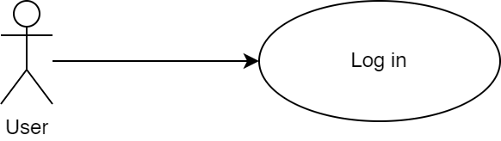

|  |  |
| --- | --- |
| Property | Value |
| ID, Name | Log in |
| Goal | A user should be granted access to the system through giving their email and password. |
| Initiator | Any user |
| Precondition | None |
| Postcondition | * The given user credentials will be granted access if their credentials were verified. |

#### Step-by-step Description

|  |  |
| --- | --- |
| 1. The actor submits a login request with their email and password. 2. The system hashes the given password to match the hashed value in the database. 3. The system checks that a user with the given email and password exists.    1. On success, the user is granted access to the site.    2. On failure, a message appears to the user notifying |  |

### Add User

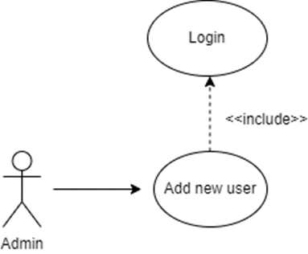

|  |  |
| --- | --- |
| Property | Value |
| ID, Name | Add new users. |
| Goal | Users should be added to the list of users. |
| Initiator | Admin. |
| Precondition | * A user with project leader or higher privileges should be logged in. |
| Postcondition | * Users should be added to the list of users. |

#### Step-by-step Description

|  |  |
| --- | --- |
| 1. The system checks that the actor is a user with admin privileges. 2. If the actor isn’t an admin, the system denies their access. 3. If the actor is an admin, the system redirects them to the “add user page”. 4. The admin proceeds to add a user to the list and enters all the details related to the user. 5. The user is then added to the database in a new row. 6. A success message is sent to the admin if the project is successfully added to the database. |  |

### View Users

|  |  |
| --- | --- |
| Property | Value |
| ID, Name | View users |
| Goal | view data of users for the user |
| Initiator | Admin |
| Precondition | * A user with project leader or higher privileges should be logged in. |
| Postcondition | * Employees data is returned to the user if found |

#### Step-by-step Description

|  |  |
| --- | --- |
| 1. The actor requests to view employees. 2. The system runs validation checks, upon the failure of any,   throws an exception.   * 1. The system checks the actor’s login validity.   2. The system verifies the query parameters of the request.  1. The system queries the database to get employees data with the given filter if exists. 2. The system returns a response carrying a success code   and all employee’s data. |  |

### Update User

|  |  |
| --- | --- |
| Property | Value |
| ID, Name | Update user |
| Goal | Inputted changes should apply to the table of users. |
| Initiator | Admin |
| Precondition | * A user with admin privileges should be logged in. |
| Postcondition | * The user’s properties will be updated. * The new user data will be returned in response. |

#### Step-by-step Description

|  |  |
| --- | --- |
| 1. The actor submits an update request to update one of the users. 2. The system runs validation checks, upon the failure of any, throws an exception.    1. The system checks the actor’s login validity.    2. The system checks that the actor is either the project leader assigned to this project or a user with higher privileges.    3. The system verifies the input format of the request. 3. The system queries the database to update the given user’s properties with the new data. 4. The system returns a response carrying a success code and the updated user’s data. |  |

### Delete User

|  |  |
| --- | --- |
| Property | Value |
| ID, Name | Delete user |
| Goal | The given user should be marked as deleted |
| Initiator | Admin |
| Precondition | * A user with admin privileges should be logged in. |
| Postcondition | * The user will be marked as deleted for further cleaning. * The user’s data is returned with a deleted status |

#### Step-by-step Description

|  |  |
| --- | --- |
| 1. The actor submits a delete request to delete one of the users. 2. The system runs validation checks, upon the failure of any, throws an exception.    1. The system checks the actor’s login validity.    2. The system checks that the actor is an admin.    3. The system verifies the input format of the request. 3. The system queries the database to update the given user’s status to be deleted. 4. The system returns a response carrying a success code and the project marked as deleted. |  |

### Add Employee

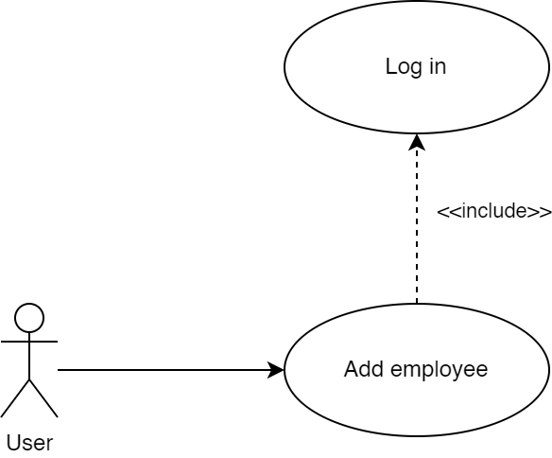

|  |  |
| --- | --- |
| Property | Value |
| ID, Name | Add new Employee. |
| Goal | Employee should be added to the database. |
| Initiator | Admin. |
| Precondition | * A user with admin privileges should be logged in. |
| Postcondition | * An employee should be added to the database. * The new employee’s data should be returned. |

#### Step-by-step Description

|  |  |
| --- | --- |
| 1. The actor sends a request to add a new employee. 2. The system runs validation checks, upon the failure of any, throws an exception.    1. The system checks the actor’s login validity.    2. The system checks that the actor is an admin.    3. The system verifies the input format of the request. 3. The system adds the new employee to the database. 4. The system returns a response with a success code and the new employee’s data |  |

### View Employees

|  |  |
| --- | --- |
| Property | Value |
| ID, Name | View employees |
| Goal | view data of employees for the user |
| Initiator | User |
| Precondition | * The user should be logged in |
| Postcondition | * Employees data is returned to the user if found |

#### Step-by-step Description

|  |  |
| --- | --- |
| 1. The actor requests to view employees. 2. The system runs validation checks, upon the failure of any,   throws an exception.   * 1. The system checks the actor’s login validity.   2. The system verifies the query parameters of the request.  1. The system queries the database to get employees data with the given filter if exists. 2. The system returns a response carrying a success code   and all employee’s data. |  |

### Update Employee

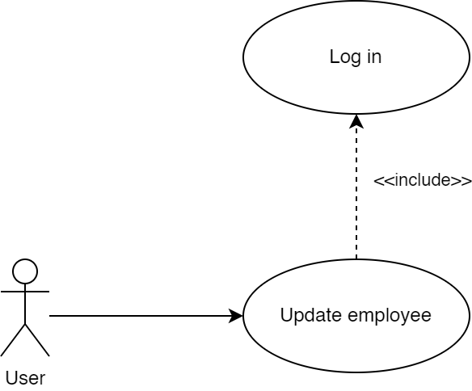

|  |  |
| --- | --- |
| Property | Value |
| ID, Name | Update Employee. |
| Goal | Employee data will be updated in the database. |
| Initiator | Admin. |
| Precondition | * A user with admin privileges should be logged in. |
| Postcondition | * An employee should be added to the database. * The new employee’s data should be returned. |

#### Step-by-step Description

|  |  |
| --- | --- |
| 1. The actor sends a request to add a new employee. 2. The system runs validation checks, upon the failure of any, throws an exception.    1. The system checks the actor’s login validity.    2. The system checks that the actor is an admin.    3. The system verifies the input format of the request. 3. The system updates the employee’s data in the database. 4. The system returns a response with a success code and the updated employee’s data. |  |

### Delete Employee

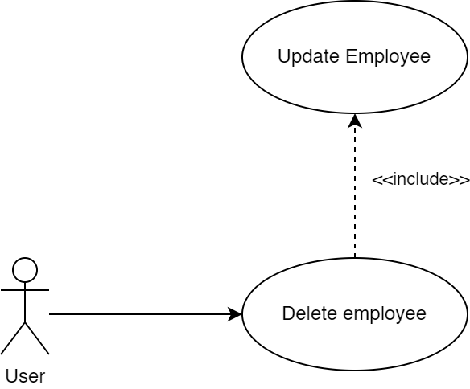

|  |  |
| --- | --- |
| Property | Value |
| ID, Name | Delete Employee. |
| Goal | Employee data will be marked as deleted in the database. |
| Initiator | Admin. |
| Precondition | * A user with admin privileges should be logged in. |
| Postcondition | * The employee will be marked as deleted for further cleaning. * The employee’s data is returned with a deleted status |

#### Step-by-step Description

|  |  |
| --- | --- |
| 1. The actor requests to delete one of the employees. 2. The system runs validation checks, upon the failure of any, throws an exception.    1. The system checks the actor’s login validity.    2. The system checks that the actor is an admin.    3. The system verifies the input format of the request. 3. The system queries the database to update the given employee’s status to be deleted. 4. The system returns a response carrying a success code and the employee marked as deleted. |  |

### Add Project

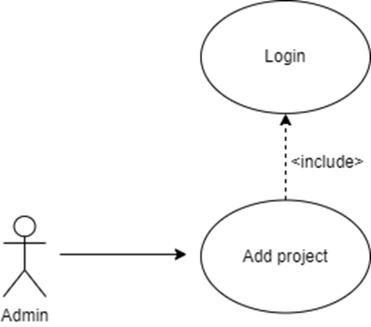

|  |  |
| --- | --- |
| Property | Value |
| ID, Name | Add project |
| Goal | Adding a project to the project list |
| Initiator | Admin |
| Precondition | * An admin should be logged in to be able to add a project. |
| Postcondition | * A project should be added to the project list by the logged in admin. |

#### Step-by-step Description

|  |  |
| --- | --- |
| 1. The system checks that the actor is a user with admin privileges. 2. If the actor isn’t an admin, the system denies their access. 3. If the actor is an admin, the system redirects them to the “add project page”. 4. The admin proceeds to add a project to the list and enters all the details related to the project. 5. The project is then added to the database in a new row. 6. A success message is sent to the admin if the project is successfully added to the database. |  |

### View Projects

|  |  |
| --- | --- |
| Property | Value |
| ID, Name | View projects |
| Goal | view data of projects for the user |
| Initiator | User |
| Precondition | * The user should be logged in |
| Postcondition | * Projects data is returned to the user if found |

#### Step-by-step Description

|  |  |
| --- | --- |
| 1. The actor requests to view other projects request. 2. The system runs validation checks, upon the failure of any,   throws an exception.   * 1. The system checks the actor’s login validity.   2. The system verifies the query parameters of the request.  1. The system queries the database to get projects data. 2. The system returns a response carrying a success code   and projects data. |  |

### Update Project

|  |  |
| --- | --- |
| Property | Value |
| ID, Name | Update project |
| Goal | Inputted changes should apply to the project table. |
| Initiator | Project Leader, Admin |
| Precondition | * A user with project leader or higher privileges should be logged in. * The project leader must be the team leader of this project. |
| Postcondition | * The project’s properties will be updated. * The new project data will be returned in response. |

#### Step-by-step Description

|  |  |
| --- | --- |
| 1. The actor submits an update request to update one of his projects. 2. The system runs validation checks, upon the failure of any, throws an exception.    1. The system checks the actor’s login validity.    2. The system checks that the actor is either the project leader assigned to this project or a user with higher privileges.    3. The system verifies the input format of the request. 3. The system queries the database to update the given project’s properties with the new data. 4. The system returns a response carrying a success code and the updated project data. |  |

### Delete Project

|  |  |
| --- | --- |
| Property | Value |
| ID, Name | Delete project |
| Goal | The given project should be marked as deleted |
| Initiator | Admin |
| Precondition | * A user with admin privileges should be logged in. |
| Postcondition | * The project will be marked as deleted for further cleaning. * The project’s data is returned with a deleted status |

#### Step-by-step Description

|  |  |
| --- | --- |
| 1. The actor submits a delete request to delete one of the projects. 2. The system runs validation checks, upon the failure of any, throws an exception.    1. The system checks the actor’s login validity.    2. The system checks that the actor is an admin.    3. The system verifies the input format of the request. 3. The system queries the database to update the given project’s status to be deleted. 4. The system returns a response carrying a success code and the project marked as deleted. |  |

### Assign Project Leaders

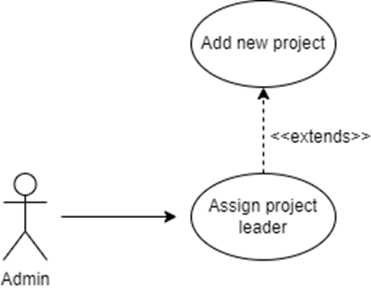

|  |  |
| --- | --- |
| Property | Value |
| ID, Name | Assign project leaders. |
| Goal | A project leader should be assigned to a project. |
| Initiator | Admin. |
| Precondition | * A user with project leader or higher privileges should be logged in. |
| Postcondition | * A project leader should be assigned to a project. |

#### Step-by-step Description

|  |  |
| --- | --- |
| 1. The system checks that the actor is a user with admin privileges. 2. If the actor isn’t an admin, the system denies their access. 3. If the actor is an admin, the system redirects them to the “assign project leaders page”. 4. The admin proceeds to assign a project leader to a project and enters all the details required. 5. The project leader is then added to the list of project leaders in the database table. 6. A success message is sent to the admin if the project leader is successfully added to the database. |  |

### Add employees to project teams

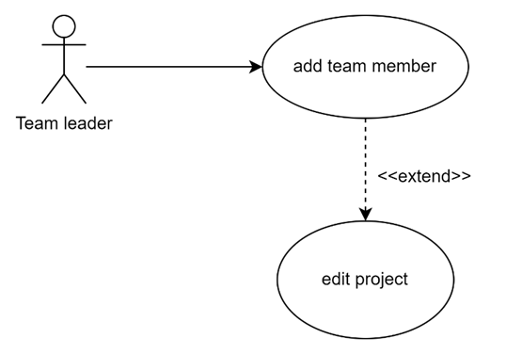

|  |  |
| --- | --- |
| Property | Value |
| ID, Name | Add Employees To Project Teams |
| Extends | Update Project |
| Goal | An employee is added to the team of the given project. |
| Initiator | Project Leader |
| Precondition | * A user with project leader should be logged in. * The project leader must be the team leader of the given project. |
| Postcondition | * The employee is added to the given project’s team. * The project team data will be returned in response. |

#### Step-by-step Description

|  |  |
| --- | --- |
| 1. The project leader searches for employees using search filters 2. The system shows the team leader a list of employees based on the filters 3. The project leader submits an update request to add a team member to one of the projects that they’re leading. By selecting an employee from the list of employees with optional filters. 4. The system runs validation checks, upon the failure of any, throws an exception.    1. The system checks the actor’s login validity.    2. The system checks that the inputted project’s leader is the logged in actor.    3. The system verifies the input format of the request. 5. The system queries the database to update the given project’s team members and add the new member 6. The system returns a response carrying a success code and the updated project data. |  |

### Mark Project as done

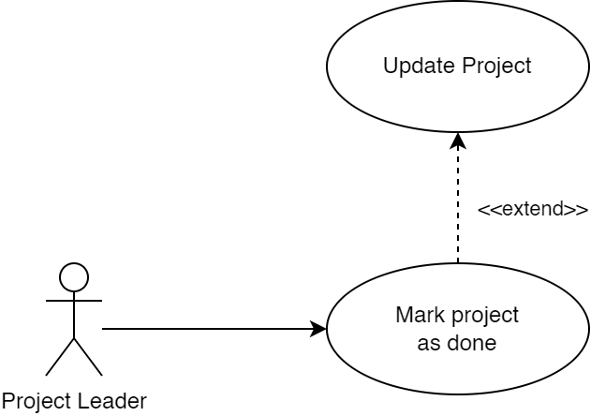

|  |  |
| --- | --- |
| Property | Value |
| ID, Name | Mark project as done |
| Extends | Update project |
| Goal | A project’s status is updated to done. |
| Initiator | Project Leader |
| Precondition | * A user with project leader or higher privileges should be logged in. * A project leader must be the team leader of this project. |
| Postcondition | * The project’s status will be updated. * The new project’s data will be returned in response. |

#### Step-by-step Description

|  |  |
| --- | --- |
| 1. The project leader submits an update request to update the status field of one of the projects that they’re leading. 2. The system runs validation checks, upon the failure of any, throws an exception.    1. The system checks the actor’s login validity.    2. The system checks that the inputted project’s leader is the logged in actor.    3. The system verifies the input format of the request. 3. The system queries the database to update the given project’s status with the done status that indicates that this project does not currently utilize any employees. 4. The system returns a response carrying a success code and the updated project data. |  |

### Update Project Capacity

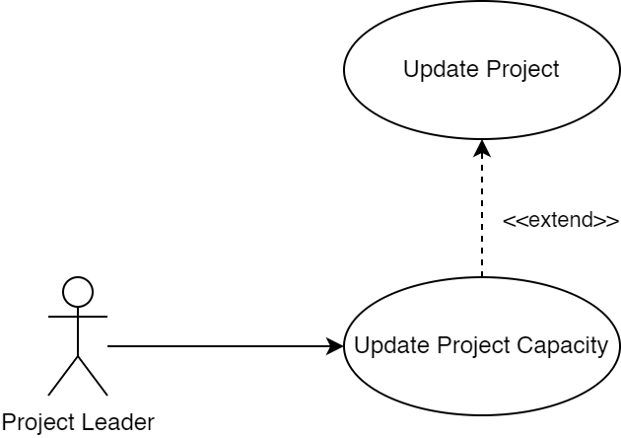

|  |  |
| --- | --- |
| Property | Value |
| ID, Name | Update project capacity |
| Extends | Update project |
| Goal | A project’s status is updated to done. |
| Initiator | Project Leader |
| Precondition | * A user with project leader or higher privileges should be logged in. * A project leader must be the team leader of this project. |
| Postcondition | * The project’s capacity is updated. * The new project data will be returned in response. |

#### Step-by-step Description

|  |  |
| --- | --- |
| 1. The project leader submits an update request to update the capacity field of one of the projects associated with one of his projects. 2. The system runs validation checks, upon the failure of any, throws an exception.    1. The system checks the actor’s login validity.    2. The system checks that the inputted project’s leader is the logged in actor.    3. The system verifies the input format of the request. 3. The system queries the database to update the given project’s capacity with the inputted capacity that indicates that this project needs a given number of employees on its team. 4. The system returns a response carrying a success code and the updated project data. |  |

### Update Employee Utilization on Project



|  |  |
| --- | --- |
| Property | Value |
| ID, Name | Update project capacity |
| Extends | Update project |
| Goal | A project’s status is updated to done. |
| Initiator | Project Leader |
| Precondition | * A user with project leader or higher privileges should be logged in. * A project leader must be the team leader of this project. |
| Postcondition | * The employee’s utilization on the given project is updated. * The new employee’s utilization data will be returned in response. |

#### Step-by-step Description

|  |  |
| --- | --- |
| 1. The project leader submits an update request to update the utilization field of one of the employees on one of his projects. 2. The system runs validation checks, upon the failure of any, throws an exception.    1. The system checks the actor’s login validity.    2. The system checks that the inputted project’s leader is the logged in actor.    3. The system verifies the input format of the request. 3. The system queries the database to update the utilization field of the employee’s utilization on the project. 4. The system returns a response carrying a success code and the updated employee’s utilization data. |  |

### View statistical details

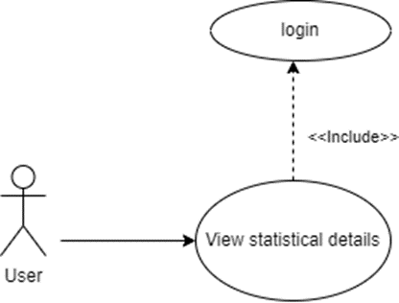

|  |  |
| --- | --- |
| Property | Value |
| ID, Name | View statistical details |
| Goal | views statistical data of sorts for the user |
| Initiator | User |
| Precondition | * The user should be logged in |
| Postcondition | * The system will aggregate statistical analysis and send it to user |

#### Step-by-step Description

|  |  |
| --- | --- |
| 1. The actor submits a view statistical details request. 2. The system runs validation checks, upon the failure of any,   throws an exception.   * 1. The system checks the actor’s login validity.   2. The system verifies the query parameters of the request.  1. The system queries the database to get statistics data. 2. The system returns a response carrying a success code and the statistics data. |  |

## Non-Functional Requirements

* User friendly interface with simple readable and simple statistics.
* Our system has high speed efficiency.
* Our system is combatable with other operating systems.